

Lettings Booklet



Contents
1. Our Objectives 3
2. Re-Lets in 2023/2024 3
3. The Allocation Process 4
What Property Size do you qualify for? 4
4. How We Let Our Properties 6
5. Assessment of Need and Award of Points 6
6. Processing Your Housing Application Form 10
7. Suspending Your Application Form 10
8. Why Would Your Housing Application Form Be Cancelled? 12
10. Complaints 12
11. Data Protection 13
What personal information do we hold and use about you and why? 13
What is our legal basis for holding and using your personal information? 14
Who do we share your personal information with? 15
Will my personal information be sent outside the UK? 15
How long do we keep your personal information? 16
What rights do you have in relation to your personal information that we hold 16
and use? 16
Feedback and complaints 16
Updates to this statement 17

How Do We Let Our Properties?

1. Our Objectives

The objectives of the Allocation Policy are as follows:

- To let our houses in an open and fair manner to people with diverse housing needs.
- To provide open access to our housing list and enable people to exercise choice about where they want to live.
- To help make EHA neighbourhoods vibrant and sustainable places for our tenants to live.
- To give high priority to addressing homelessness.
- To make the most effective use of available housing stock, and manage the turnover of lettable properties in an efficient manner.
- To comply with all statutory and regulatory requirements relating to housing applications and allocations.

2. Re-Lets in 2023/2024

To provide you with an understanding of the number of properties that become available each year, the table below details the number of properties broken down by area, street, size that were relets during the financial year 2023/2024.

Street /Area | Bedsit | 1 Bedroom | 2 Bedroom | 3 Bedroom | 4 Bedroom
Elderpark
Garmouth Gardens | 0 | 3 | 1 | 0 | 0
Uist Street | 0 | 6 | 6 | 1
Elderpark Street | 2 | 2 | 8 | 2 | 0
Langlands Road | 3 | 7 | 3 | 0 | 0
Garmouth Street | 0 | 1 | 0 | 0 | 0
Crossloan Road | 0 | 4 | 1 | 1 | 0
Nimmo Drive | 0 | 3 | 2 | 0 | 0
Harmony Row | 0 | 3 | 0 | 0 | 0
Fairfield Gardens | 0 | 1 | 0 | 0 | 0
Craigton Road | 0 | 4 | 1 | 0 | 0
Street /Area | Bedsit | 1 Bedroom | 2 Bedroom | 3 Bedroom | 4 Bedroom
Ibrox
Clynder Street | 0 | 1 | 2 | 0 | 0
Skene Road | 0 | 2 | 0 | 0 | 0
Brighton Place | 0 | 2 | 0 | 0 | 0
Summertown Road | 0 | 2 | 0 | 0 | 0
Breakdown of Lets 2023/2024 | 5 | 41 | 24 | 4 | 0
Total Lets 2023/2024 | 74

3. The Allocation Process

What Property Size do you qualify for?

We aim to make best use of our housing stock and the size of property an applicant is eligible for will depend on the number and make up of people on the housing application as detailed below

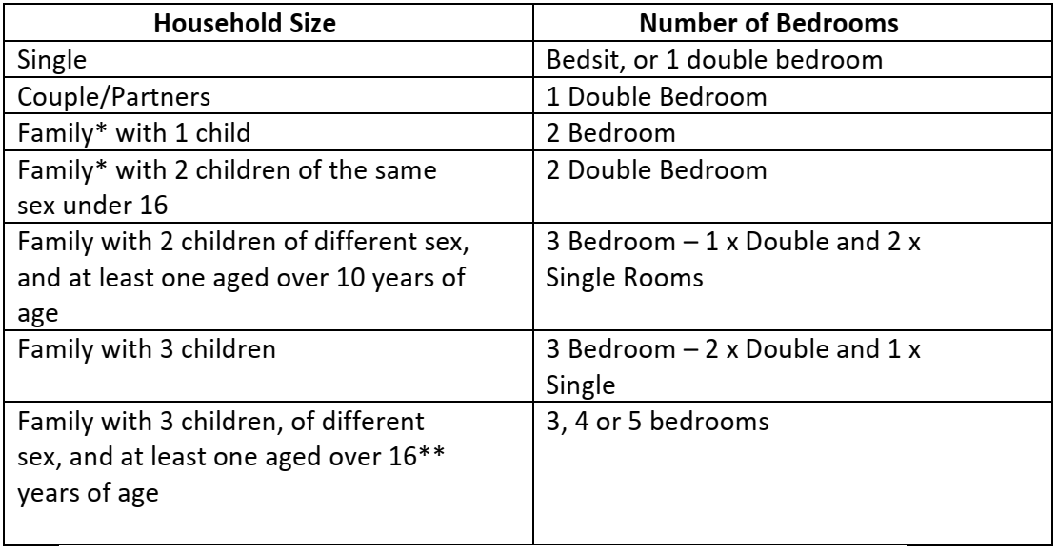

*A family is defined as a couple or a single parent with at least one child
** Children over aged 16 years of age are entitled to a room of their own

4. How We Let Our Properties

In order to maintain a balance between the various categories of lets, we operate a quota system. Target percentages for the different categories are details below:

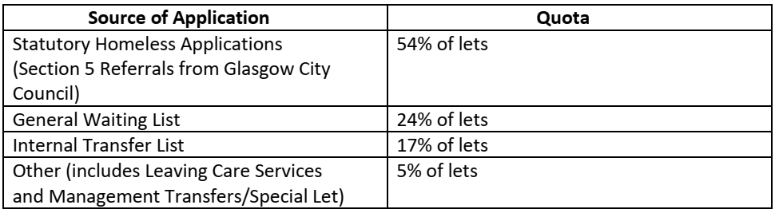

The above quotas will be subject to review on an annual basis.

The percentages outlined in the quotas are not absolute figures which must be attained.

Rather, they show how we hope to ensure a balance in our overall annual lettings to each group.
An imbalance in quotas towards the end of the year will therefore mean that we should not necessarily make lets to redress the imbalance in order to catch up.

We will ensure selections are made on a rotational basis to help ensure that quotas are broadly achieved on an ongoing basis. To assist this process monthly outcome reports detailing allocations made will be prepared.

5. Assessment of Need and Award of Points

This section outlines how we assess the needs of each applicant and let homes in a fair and consistent way to ensure those in greatest need are housed whilst making the best use of our housing stock. Underpinning our allocation policy, is the applicant’s choice to select their preferred areas and house types.

The table on the next pages outlines the points that will be awarded to each applicant based on their circumstances

Housing Need | Definition |  | Points
Urgent and  Exceptional housing need | Extreme and very urgent circumstances requiring supporting evidence from Police Scotland or other recognised agency e.g. Social Work. This includes applicants currently experiencing domestic abuse, hate crimes or other serious harassment. Aspirational needs will not be considered under this category.  e.g. demolition/leaving armed forces/hospital discharge/ leaving supported  accommodation  Such applications will be reviewed every 3 months | 100
Homelessness | Statutory Homeless by the Local Authority including refugees (Section 5’s) | 50
Insecure Tenant | You can receive points from this group if you do not have secure accommodation or are threatened with homelessness in the next 3 months.
 | you live in private rented accommodation and your lease has expired or you have been served with a notice to quit by your landlord through no fault of your own  You own your property and it is at risk of repossession | 40
 | you live in tied accommodation and your employer has told you that you will have to leave your accommodation within the next 6 months (for example, as a result of retirement or redundancy) | 40
Sharing Amenities | Applicants who do not have their own home and lodge in someone else's homethis includes sons/daughters residing with parents and those living with family or friends; | 20

Overcrowding | This group is designed to provide points if you are living in accommodation that is not large enough for the people living with you. This is only awarded if you are the tenant/owner of the property. You will receive points if you need:
 | • 1 extra bedrooms | 20
 | • 2 extra bedrooms | 40
 | • 3 extra bedrooms | 60
Under occupying | This group is designed to provide points if you are living in accommodation that is too large for you – This is only awarded to social tenants:
 | • 1 extra bedrooms | 20
 | • 2 extra bedrooms | 40
 | • 3 extra bedrooms | 60
Below Tolerable standards | Applicant living in a property that has been assessed as Below Tolerable Standard – Local Authority confirmation is required | 30
Harassment, Abuse,  Discrimination or  Victimisation | Where an individual household is the target of a campaign of harassment, this will generally be supported by evidence from the police, Social Work Services or other support agency and/or the landlord although, particularly in the case of racial harassment. | 40
Relationship Breakdown | you are in a relationship that has broken down and you are  unable to remain in the home | 30
Social Needs | To be near relatives for support  •Access medical treatment/social services facilities  • Employment or education purposes/move closer to work | 15
Medical | Complex Medical  • A member of the household has an  illness/disability/health  condition that is | 50
seriously affected by the current housing circumstances and would be alleviated if they moved to a specific house type
• Due to an assessed limited mobility a person in the household is unable to access essential parts of the property and it is unsuitable for adaptation (e.g.
bathroom upstairs)
 | Medical Applicants who live in unsuitable housing due to a medical condition/disability but are not housebound and their life is not at risk due to their current housing. Note:  Assessment is not made on the basis of health but how the accommodation is impacting on the individual’s health. | 30

6. Processing Your Housing Application Form

Before we can process your application we need the following information:

Your name and address, national insurance number, date of birth, household composition, proof of your identity and proof of address within the last 3 months.

In acknowledging your application form we will confirm what points you have been awarded, the size of the property you will be considered for and the category of your application.

Before we offer you a property we may contact you to carry out a pre-tenancy interview and verify your details. We also need details of previous residencies and a reference if appropriate from you current or previous landlord. The purpose of this is to confirm your housing circumstances and advise of agencies that may be useful in helping you with your tenancy obligations.

7. Setting up a home

Accepting a tenancy and setting up a home comes with significant responsibilities. Below are some key things you should be mindful of when accepting a property offer

Rent Payments

When the association offers you a tenancy, you will need to pay your first month's rent in advance. If your household qualifies for Housing Benefit or Universal Credit, make sure to update your Universal Credit journal with your new tenancy details to ensure payments begin from the tenancy start date. Failing to do so could lead to rent arrears.

Decorating and Furnishing your property

When you move into your home, it is your responsibility to decorate and furnish the property. All of our homes are unfurnished and do not include white goods like washing machines or cookers. Most properties also lack floor or window coverings. In some cases, flooring and blind packages may be available, but these are subject to specific conditions. Therefore, it's important to plan how you will finance the decorating and furnishing of your home.

How can Elderpark Support you living in your home

When you accept the tenancy offer, you will need to meet with your designated housing officer to complete the tenancy agreement and other necessary paperwork. The housing officer's role is to assist you with any matters related to your tenancy at Elderpark. They can also offer support by referring you to other services available through the association, such as:
- Support from our Energy Advisor to tackle fuel bills and fuel debt
- Support from our Financial Inclusion Officer to ensure you are in receipt of all of the benefits you are entitled to
- Support from our Tenancy Sustainment Officer who can help to link you in with support networks you may require such as getting back into employment/addiction and health services and also provide support with budgeting and advocacy on housing related issues

8. Suspending Your Application Form

In some specific circumstances, applicants may be suspended from the housing register. We have a clear process in place which sets out the criteria for the suspension, the length of time an applicant will be suspended and what they are required to do to reinstate their housing application. Applicants will be advised of this in writing and also of their right to appeal the decision.

Reason for Suspension | Length of Time Application will be Suspended | How the Suspension can end
Current or Previous Housing  Debt | The application will remain suspended until the debt has been repaid in full, or a repayment arrangement has been maintained for 3 consecutive months. | Applicants will be reinstated when they confirm to us that the debt has been repaid in full or they have maintained a repayment arrangement for at least three months. If the applicant makes no contact with us to confirm this within 12 months, the application will be closed.
It can be shown that the applicant intentionally provided false information during the application to gain more points | Until accurate information has been provided by the applicant. | The suspension will end when the applicant has provided true and accurate information
Clear evidence of anti-social behaviour associated with the occupancy of property or within  the local vicinity | 1 year | Review after 12 months where it can be shown whether behaviour has been satisfactory
Conviction or eviction for antisocial behaviour associated with occupancy of property or within the local vicinity | 2 years | Review after 24 months where it can be shown whether behaviour has been satisfactory
Acted in an antisocial manner, or pursued a course of conduct which is antisocial conduct, in relation to an employee of the social landlord in the course of making the application. | 1 year | Review after 12 months
Where an applicant has abandoned or neglected a tenancy/previous tenancy | 1 year | Review after 12 months
Your home including garden or common areas are kept in an unsatisfactory condition | Until property is brought up to an acceptable standard | Review once you can show the property is in a satisfactory condition
Where an applicant has refused  3 reasonable offers of housing | 12 months | Applicants will be  reinstated after 12  months
If we receive an unsatisfactory reference from your current or former landlord for the past 3 years for anyone on your application. | Up to 6 months | When a satisfactory reference is received or when you can show you can maintain a tenancy in a satisfactory way – whatever is the soonest.

9. Why Would Your Housing Application Form Be Cancelled?

An application will be cancelled from the list under the following circumstances:

  - When an applicant has been re-housed or they have changed address
  - When an applicant did not reply to our waiting list review letter
  - When an applicant has requested that the application is taken off the list
  - When an applicant dies

10. How Do I Appeal the Points I have been awarded?

Separate from the Complaints Procedure, there is an appeals process within the Allocation Policy to deal with instances where an applicant is unhappy about a decision made about their application. An applicant can appeal if they think that:

- The priority they have been awarded does not reflect their needs
- They have been unfairly suspended from the housing register or their application has been cancelled unreasonably
- Their priority has been removed unreasonably because they have refused offers of housing
- The house they have been offered does not match the choice on their application
- They have been offered a house that is in an unacceptable condition
- We have refused to make an offer of housing

The timescale for submitting an appeal is up to 21 days from the date of the decision
being made. An appeal will be investigated by the Housing Manager, who will respond to the applicant within 10 working days of receiving the appeal.

If the applicant remains dissatisfied with the response the applicant may request that the case is considered by the Director of Housing. This is the final stage of the Appeals process.

11. Complaints

Appeals must be distinguished from complaints for which a separate procedure exists.

Details of how to complain are contained in a separate leaflet entitled ‘Complaints Booklet’ which can be obtained at our main office or via the website: www.elderpark.org . The complaints procedure details the timescale the Association has to resolve different types of complaints.

If you are dissatisfied with the outcome of your complaint after the Association has completed its investigation or to seek other independent advice please contact the details the Scottish Public Services Ombudsman below :

Scottish Public Services Ombudsman
4 Melville Street
Edinburgh, EH3 7NS
Telephone 0870 011 5378 Email: enquiries@scottishombudsman.org.uk

12. Data Protection

We, Elderpark Housing Association, are the controller of the personal information that we hold about you. This means that we are legally responsible for how we hold and use personal information about you. It also means that we are required to comply with data protection laws when holding and using your personal information. This includes providing you with the details contained within this statement of how we hold and use your personal information, who we may share it with and your rights in relation to your personal information.

We have appointed a Data Protection Officer (DPO) who ensures we comply with data protection laws. If you have any questions about this statement or how we hold or use your personal information, please contact the DPO by: e-mail at gdpr@elderpark.org; telephone on 0141 440 2244; or writing to: Data Protection Officer, Elderpark Housing Association, 65 Golspie Street, Glasgow, G51 3AX.

You can contact us by: e-mail at admin@elderpark.org; telephone on 0141 440 2244; or writing to: Elderpark Housing Association, 65 Golspie Street, Glasgow, G51 3AX.
Your attention is particularly drawn to section 2 of this statement, which confirms that you consent to your personal information and special category personal information being held and used by us as described in section 1 of this statement.

What personal information do we hold and use about you and why?

As part of your tenancy agreement with us, we hold and use the personal information that you provided to us in your housing application form, that the third parties who referred you to us provided to us and / or other personal information that we may obtain about you from you and third parties on an ongoing basis.
We use such personal information for the following purposes:
• providing you with services as the landlord of your property;
• communicating with you, including in response to any of your enquiries;
• improving our services and responding to changing needs;
• tenancy management and administration, including: processing your rent
payments (including entering into rent payment arrangements with you); carrying
out repairs to your property (including recharging such repairs to you, if relevant);
assessing your housing needs; making special adaptations to your property;
completing safety and other periodic maintenance checks to your property;
handling and resolving complaints made by / against you; and recovering any rent
arrears;
• keeping the personal information that we hold about you accurate and up-to-date;
• completing satisfaction and other surveys and consultations;
• complying with our legal and statutory duties, including those contained within the
Equality Act 2010;
• publishing our newsletter and other communications in hard copy format, on social
media and on our website;
• allowing you to take part in our tenant participation and engagement activities (if
you choose to do so);
• preparing and submitting our annual return on the Scottish Social Housing Charter
to the Scottish Housing Regulator;
• providing you with benefits, budgeting and debt advice, and signposting you to
organisations that can offer further advice and support to you;
• determining whether you are to be classed as a “no lone visit”, based on our
assessment of your conduct and / or the complaints that we have received about
you;
• assisting with crime prevention and detection;
• protecting individuals from harm;
• compiling statistical information and returns to our Committee and the Scottish
Housing Regulator; and
• providing a reference on request if you move to another landlord.

What is our legal basis for holding and using your personal information?

Data protection laws require us to have a legal reason for holding and using your personal information. Our legal reasons for holding and using your personal information are:
• performance and management of the tenancy agreement between us;
• legal and regulatory obligations which apply to us as a registered social landlord;
• protection of your vital interests; and
• our legitimate interests – while you have a legitimate interest in the protection of
your personal information, we also have an overriding legitimate interest in
handling and using your personal information, including sharing it with third parties
(listed in section 3 of this statement), for the purposes described in section 1 of this
statement.

In some circumstances, we may rely on your consent as the legal reason. By providing us with your personal information and special category personal information (relating to your health, racial or ethnic origin, religious or other beliefs or sexual orientation) and the personal information and special category personal information of other members of your household, you:
• consent to it being used by us as described in section 1 of this statement; and
• confirm that you have informed the other members of your household of 12 years
old and above of the content of this statement and they have provided their consent
to their personal information and special category personal information being used
by us as described in section 1 of this statement.

You and the other members of your household have the right to withdraw your consent to us holding and using your and their personal information and special category personal information by contacting us. Once you / they have withdrawn your / their consent, we will no longer use your / their personal information and special category
personal information for the purpose(s) set out in section 1 of this statement, which you originally agreed to, unless we have another legal reason for doing so.

Who do we share your personal information with?

We share your personal information with the following organisations for the purposes described in section 1 of this statement:
• our contractors to undertake repairs, works and maintenance to your property;
• our service providers to maintain the systems on which your personal information
is stored, including our housing management software, and to allow you to make
rent payments to us;
• our auditors to carry out audit inspections;
• our insurers in the event of a claim being made against us;
• our survey company to undertake satisfaction surveys on our behalf;
• utility companies to manage payment of utilities for your property, including
payment by you of any outstanding debts to utility companies after commencement
and / or termination of your tenancy;
• our energy management service to assist in finding the best energy deals for you;
• the local authority for allocation of housing, notifying the local authority when we
raise court proceedings against you to recover possession of a tenancy and
compliance with our obligations under the data sharing agreements that we have
entered into with the local authority;
• the Department for Work and Pensions for the assessment of benefits payable /
paid to you;
• our solicitors for providing advice on debt recovery actions, anti-social behaviour,
evictions and other tenancy-related matters;
• our debt collection and tracing agents for the recovery of rent arrears;
• Police Scotland, Scottish Fire and Rescue Service and the local authority antisocial behaviour department, if you engage in anti-social or other criminal
behaviour while our tenant;
• Scottish Public Services Ombudsman as part of our complaints procedure;
• Scottish Housing Regulator as part of complying with the regulatory requirements
that apply to us;
• third parties who undertake mailings on our behalf; and
• other landlords when providing a reference for you.

Will my personal information be sent outside the UK?

Some of the organisations who we share your personal information with (listed in section 3 of this statement) may be based or may make use of data storage facilities that are located outside the UK. Their handling and use of your personal information will involve us and / or them transferring it outside the UK. When we and / or they do this, we will ensure similar protection is afforded to it by:
• only transferring it or permitting its transfer to countries that have been deemed to
provide an adequate level of protection for personal information as a matter of data
protection law; or
• using specific contracts with such organisations, which are approved for use in the
UK, and which give your personal information the same protection it has in the UK.

Please contact our DPO for further information on the specific mechanism used by us when transferring your personal information outside the UK.

How long do we keep your personal information?

We will only keep your personal information for as long as we need to for the purposes described in section 1 of this statement, including to meet any legal, accounting, reporting or regulatory requirements. More information is contained in our data retention policy, which is available by contacting our DPO.

What rights do you have in relation to your personal information that we hold

and use?

It is important that the personal information that we hold about you is accurate and current. Please keep us informed of any changes by contacting our DPO. Under certain circumstances, the law gives you the right to request:
• A copy of your personal information and to check that we are holding and using it
in accordance with legal requirements.
• Correction of any incomplete or inaccurate personal information that we hold about
you.
• Deletion of your personal information where there is no reason for us continuing to
hold and use it. You also have the right to ask us to do this where you object to us
holding and using your personal information (details below).
• Temporarily suspend the use of your personal information, for example, if you want
us to check that it is correct or the reason for processing it.
• The transfer of your personal information to another organisation.
You can also object to us holding and using your personal information where our legal basis is a legitimate interest (either our legitimate interests or those of a third party).
Please contact our DPO if you wish to make any of the above requests. When you make a request, we may ask you for specific information to help us confirm your identity for security reasons. You will not need to pay a fee when you make any of the above requests, but we may charge a reasonable fee or refuse to comply if your request for access is clearly unfounded or excessive.

Feedback and complaints

We welcome your feedback on how we hold and use your personal information, and this can be sent to our DPO.
You have the right to make a complaint to the Information Commissioner, the UK regulator for data protection, about how we hold and use your personal information. The ICO’s contact details are as follows:
Telephone: 0303 123 1113
Website: https://ico.org.uk/concerns/

If you would like to receive this statement in alternative format, for example, audio, large print or braille, please contact us.

Updates to this statement

We may update this statement at any time, and we will provide you with an updated version when we are required to do so by law.

A full copy of the Allocations Policy is available by contacting 0141 440 2244 admin@elderpark.org

