Managing Mould & Condensation

*A guide for tenants*





**Your guide to damp and mould**

Damp and mould in the home can be a health hazard, causing respiratory problems and exacerbating allergies. Making sure your home is free of mould and damp is not only important for your health, but it is also your responsibility as a tenant. Preventing damp and mould is much easier than you might think. This quick guide explains how some everyday habits contribute to damp indoors and offers simple solutions to minimise and deal with small damp and mould issues.

**How to prevent damp and mould**





**Keep doors closed**

Keep bathroom or kitchen doors closed when having a shower or bath, or when cooking. This will prevent moisture from spreading to other parts of the property.

**Air your property regularly**

Open windows regularly to make sure your property is well-ventilated. Even when it’s cold, moisture can gather in the home. Opening the window allows some of this moisture to escape. Leave window vents open at all times to allow good circulation.

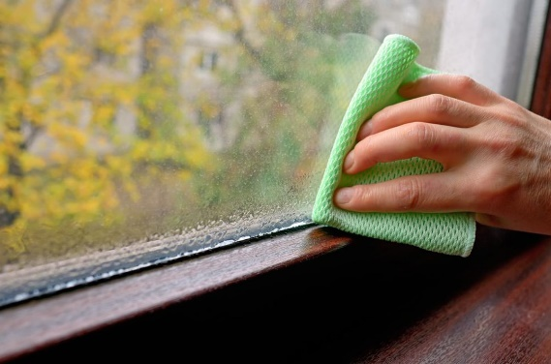

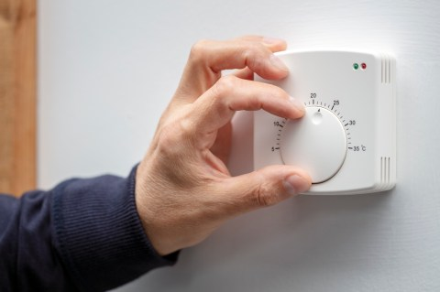

**Turn your heating on**

Running your heating can avoid cold spots, dry out damp, and reduce your chances of getting mould.

**Wipe away condensation**

Cleaning the condensation from windows and frames every day will minimise the spread of black mould. You can use a rag or towel to wipe away condensation. Leave window vents open at all times to allow good circulation.

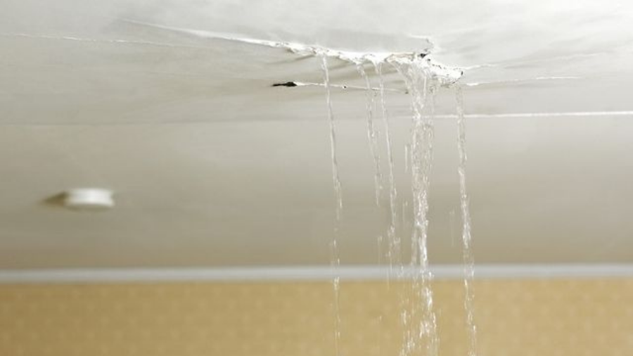

**Keep an eye out for leaks**

Leaky window frames, pipework, walls and doors are common sources of moisture. If you see a leak, you should report it to us as soon as possible so we can deal with the problem swiftly. This will also stop the issue from turning into more serious problems and cause further damage to the property. In the meantime, use a bucket or bowl to collect any drips and make sure to keep surfaces dry with a mop or towel.

**Dry clothes in a ventilated room**

Don’t dry clothes on radiators. The vapour turns into moisture in the air and is then circulated around the rooms. This then gathers on walls, windows and other fabrics in the home and can be a mould risk. Instead, dry clothes on a clothes airer in a well-ventilated room. Open a window or use a dehumidifier to minimise the spread of moisture indoors.

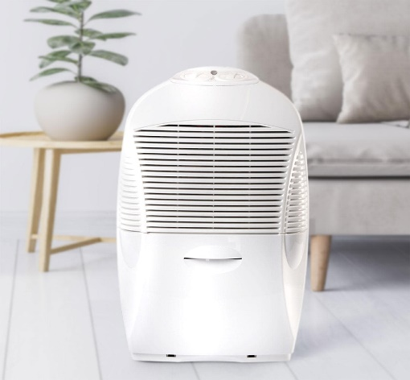

**Dehumidifiers and damp traps**

Using a dehumidifier is a great way to take the moisture out of the air, especially if you dry your clothes indoors. You can buy an inexpensive one from a local hardware store or online.

Disposable damp traps can be cheaper, but over time, you might find it more economical (and environmentally friendly!) to use an electric dehumidifier.

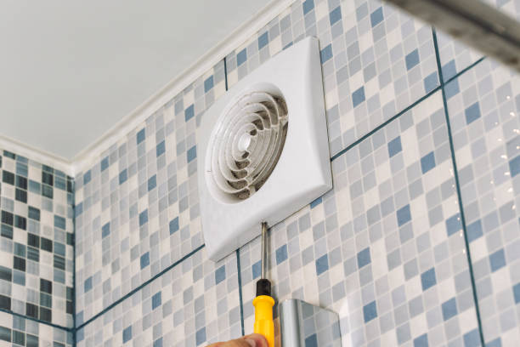

**Use extractor fans**

If you have an extractor fan in the bathroom, always make sure it is running when you’re having a shower or bath. If you have an extractor fan in the kitchen, you should also use it to disperse moisture and cooking smells.

If you don’t have an extractor fan, open a window when you cook to allow the moisture to escape.

Leave window vents open at all times to allow good circulation.

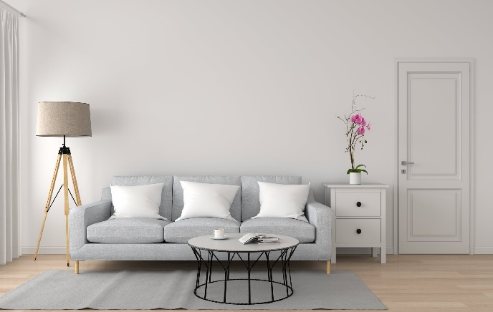 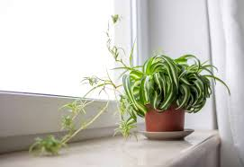

**Grow moisture absorbing plants**

Some plants can absorb moisture and pollution from the air and are a great addition to your damp prevention arsenal. Peace lilies, tillandsia, palms and ferns are all moisture absorbers – some ferns actually thrive in damper rooms such as kitchens and bathrooms, just make sure you also give them some indirect sunlight.

**Don’t overfill your home**

Avoid pushing furniture against the wall, or overfilling wardrobes as this can cause damp and mould to grow and spread. Check behind furniture regularly for signs of damp or mould developing.