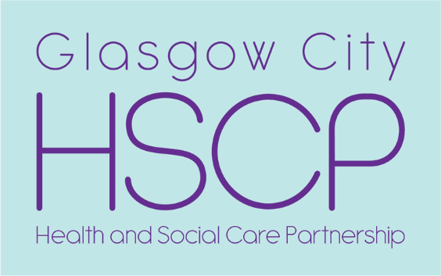

South Community
Homelessness Service

The South Community Homelessness Service deliver a homelessness service to anyone who is homeless, threatened with homelessness, or is in need of advice about homelessness issues. If you think you are homeless, or at risk of becoming homeless, please contact the Homeless Casework Team for more information.

South Community Homelessness Service office is based at:

Rowan Business Park
5 Ardlaw Street,
Glasgow
G51 3RR
Tel: 0141 287 0555/0141 276 8201

The service operates between the hours of:
Monday to Thursday: 8:45am – 4:45pm
Friday: 8:45am – 3:55pm

