Factoring Policy
If you have difficulty with sight or hearing, or if you require this document translated, please contact us and we will be happy to provide this information in a format that suits your needs.

Our Vision, Our Mission, Our Values
Our Vision
Elderpark Housing will lead the way in delivering outstanding customer services and great places to live.
Our Mission
To provide quality, affordable homes and excellent services which place a focus on our customers and enhancing our communities.
Our Values
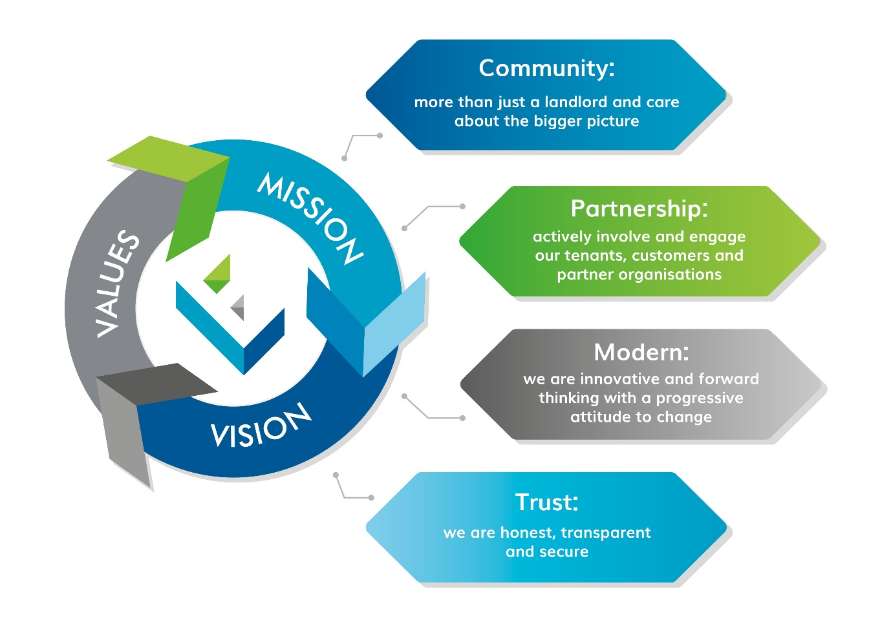
Equality and Diversity Statement
Elderpark Housing are committed to ensuring people or communities do not face discrimination or social exclusion due to any of the following protected characteristics: age; disability; gender reassignment; marriage and civil partnership; pregnancy and maternity; race; religion and belief; sex or sexual orientation.
This document complies with our Equalities and Diversity Policy.
We will regularly review this Policy and consider any equalities implications taking the necessary action to address any inequalities (either directly or indirectly) that result from the implementation of this Policy.
Executive Summary

Introduction

The Director of Housing and Customer Services, in consultation with the Director of Finance and Corporate Services and the Director of Maintenance and the Housing Services Officer has developed this policy and the accompanying written statement on behalf of the organisation.

Purpose of the Policy
This policy sets out the legislation and guidance that the Association has taken into account as part of the review of the Factoring Service. This is demonstrated by the Written Statement which outlines how we offer a transparent factoring service to owners. The purpose of which is to maintain the fabric of the building and common arears to a high standard and promote a safe and secure environment.

Aims and Objectives of the Policy
A main objective of this policy is that the factoring service adheres to the Code of Code for Property Factors. Other internally focused objectives include
- Maintain accurate information and utilise the capacity of our I.T system to help provide an effective service.
- Account clearly for monies held on behalf of owners including advance payments and sinking funds.
- Take appropriate action to recover all monies due.
- Provide owners with the opportunity to participate in the Association’s decision making process in relation to factoring or wider community development initiatives.
- Provide owners with benefits of having a factor who is also a community based social landlord.

Legislative and Regulatory Compliance

The Association’s Factoring service will conduct its business in a manner that complies with relevant legislation. This includes;

- The title Conditions ( Scotland) Act 2003
- The Tenements Scotland Act 2004 – The Tenement Management Scheme
- The Housing (Scotland) Act 2006, 2016, and 2001/2010
- The Property Factors (Scotland) Act 2011 – The Code of Conduct.
Equalities
Elderpark Housing will ensure there is a consistent approach in promoting equality and diversity across all areas and this policy will be administered in accordance with the Equalities and Diversity policy.

It is our conscious consideration that the implementation of this proposed policy will not have a negative impact, or in any way lead to discrimination, of the protected characteristic groups as identify in equality legislation.

Privacy
This document fully complies with General Data Protection Regulations (2018) and will be published on our website to ensure transparency.

Related Policies
Policy Title | Location
Standing Orders Policy | V:\Elderpark Policy Suite\Governance Policies\G5 Delegation Expenditure Authorisation Limits.xlsx
Complaint Handling Policy | https://elderpark.org/wp-content/uploads/2021/07/G9-Complaints-Handling-Policy-and-Procedure.pdf
Procurement Policy | https://elderpark.org/wp-content/uploads/2019/10/G-28-Procurement-Policy.pdf
Equality & Diversity Policy | V:\Elderpark Policy Suite\Governance Policies\G13 Equality and Diversity Policy.pdf
Estate Management Policy | V:\Elderpark Policy Suite\Housing Management Policies\H5 Estate Management Policy.pdf
Planned Maintenance Policy | V:\Elderpark Policy Suite\Maintenance Policies\M3 Planned and Cyclical Maintenance Policy.pdf

Contents Page

- Purpose of the Policy Page 5

- Aims and Objectives of the Policy Page 5

- Legislative and Regulatory Compliance Page 7

- The Service Provision and the Written Statement Page 8

- Implementation and Responsibility Page 8

- Linking Owners with our Community Ethos

and Mission Statement Page 9
- Monitoring of the Policy Page 9

- Reporting on Outcomes Page 10

- Complaints Page 10

- Publicity Page 10

- Policy Review Page 10

Appendices
Appendix 1 Headings in the Written Statement

1.0 The Purpose Of This Policy
This policy sets out the legislation and guidance that the Association has taken into account as part of the review of the Factoring Service. This is demonstrated by the Written Statement which outlines how we offer a transparent factoring service to owners. The purpose of which is to maintain the fabric of the building and common arears to a high standard and promote a safe and secure environment.

The principles of the service mirror both the values of Elderpark, of being community focussed and offering modern services based on trust and partnership. This links in with the Code of Conduct for Factoring which emphasises the need for accurate record keep, being transparent, adhering to legislation, having good communication which is open and transparent.

2.0 Aims and Objectives of the Policy
2.1 Below are the overarching standards of practice that property factors should apply in carrying out their work, as specified in the Code of Conduct. They also represent the aims and objectives of this policy which are;
● You must conduct your business in a way that complies with all relevant legislation.
● You must be honest, open, transparent and fair in your dealings with homeowners.
● You must provide information in a clear and easily accessible way.
● You must not provide information that is deliberately or negligently misleading or false.
● You must apply your policies consistently and reasonably.
● You must carry out the services you provide to homeowners using reasonable care and skill and in a timely way, including making sure that staff have the training and information they need to be effective.
● You must not unlawfully discriminate against a homeowner or prospective homeowner because of their age, disability, sex, gender reassignment, being married or in a civil partnership, being pregnant or on maternity leave, race including colour, nationality, ethnic or national origin, religion, belief or sexual orientation.
● You must ensure all staff and any sub-contracting agents are aware of relevant provisions in the Code and your legal requirements in connection with your maintenance of land or in your business with homeowners in connection with the management of common property.
● You must maintain appropriate records of your dealings with homeowners and prospective homeowners. This is particularly important if you need to demonstrate how you have met the Code’s requirements.
● You must respond to enquiries and complaints within reasonable timescales and in line with your complaints handling procedure.
● You must not communicate with homeowners in any way that is abusive, intimidating or threatening.
● You must ensure you handle all personal information sensitively and in line with legal requirements on data protection.

  - Other main objectives of the Policy include;

● Maintain accurate information and utilise the capacity of our I.T system to help provide an effective service.

● Account clearly for monies held on behalf of owners including advance payments and sinking funds.

● Take appropriate action to recover all monies due.

● Provide owners with the opportunity to participate in the Association’s decision making process in relation to factoring or wider community development initiatives.

● Provide owners with benefits of having a factor who is also a community based social landlord.

3.0 Legislative and Regulatory Compliance
The Association’s Factoring service will conduct its business in a manner that complies with relevant legislation. This includes;
  - The main statutory Legislation which applies to Property Factoring is detailed below.

● The title Conditions ( Scotland) Act 2003
● The Tenements Scotland Act 2004 – The Tenement Management Scheme
● The Housing (Scotland) Act 2006, 2016, and 2001/2010
● The Property Factors (Scotland) Act 2011 – The Code of Conduct.

3.2 Compliance with guidance includes;
● The Scottish Social Housing Charter. This contains 16 outcomes and standards that social housing landlords housing landlords should aim to achieve. The standards that relate to Factoring include;
1. Equalities 2. Communication , 3. Participation & 13. Value for Money
- The Scottish Government Revised Code of Conduct for Registered Factors, ( final Draft September 2020)

  - Other legislative and regulatory compliance relating to the policy are:

● The Equality Act 2010.
● Data Protection Act 2018.
● The General Data Protection Regulations 2018.
● The Construction, Design and Management Regulations 2015 and Health and Safety at Work Act 1974.
● The Control of Asbestos at Work Regulations 2002.
● Legionella: The Approved Code of Practise.
● The occupiers Liability ( Scotland ) Act 1960.
● Freedom of Information (Scotland) Act 2020.

4.0 The Service Provision and the Written Statement

The Written Statement complies with the Code of Conduct which sets out minimum standards to encourage transparency in the way that Elderpark, as a property factor conducts its business with homeowners.

The written statement is a simple, structured document which outlines the terms and service delivery standards of the arrangements in place between Elderpark and homeowners. In the event of a hearing at the First-tier Tribunal for Scotland Housing and Property Chamber Elderpark will be expected to demonstrate how our actions compare with their written statement of services and this needs to comply with the requirements of this Code of Conduct

The written statement is a procedural document which demonstrates compliance with the Code of Conduct and has regard to the aforementioned legislation and guidance. Details of the heading covered in the Written statement are detailed in Appendix 1

Implementation and Responsibility
The Management Committee, in its formal approval of the Policy, accepts full responsibility for the policy and ensures its implementation.
The Director of Housing and Customer Services will register with the Property Factor as the responsible/relevant person acting for the factor. They must complete a Fit and Proper Person Declaration and will oversee to ensure that the factoring service complies with the Code of Conduct.

Compliance of the policy is dependent on strong interlinked working relationships and ensuring that factoring considerations are taken into account when reviewing policies as detailed in 4.3 in this policy.

Staff will be appropriately trained and familiar with duties and requirements imposed by the code of Conduct and have the knowledge required to provide a high quality factoring service.

The roles of staff are set out in the Written Statement, Point 11. Roles and Contact Details of Key Staff. These staff have a responsibility to ensure that the policy and the written statement is applied as instructed.

Owner Occupiers and our Community Ethos as a Registered Social Landlord.
Elderpark values include “Community” in that we are more than a landlord and care about the bigger picture. We therefore wish to offer owners’ additional services which will help support the wider community. This includes:
- Offering a welfare rights services to owners.
- Encouraging and welcoming owners as members of Elderpark Housing.
- Promoting community development opportunities to owners.
- Offering Mortgage to Rent as a housing options, subject to government conditions.
- Where appropriate, seek funding for owners to help maintaining the fabric of their building.

Monitoring of the Policy:

The implementation and review of policy and practise will be carried out by:
- The Policy and procedures will be audited as determined by our Internal Audit Process, the outcome of which, will be reported to the Management Committee
- Review the written statement based on customer feedback and complaints, best practise updates and decision of First-tier Tribunal.
- Ensure good communication between the Housing, Maintenance and Finance &Corporate Services Teams
- Staff attending training and conference on Factoring

Reporting on Outcomes

The following areas will be subjected to monitoring on a regular basis and reported to the Management Committee, or sub-committee on an annual basis:
- The level of customer satisfaction through customer feedback, satisfaction surveys and analysis of complaints procedures.
- The level of factoring arrears.
- The outcome of consultation on proposed increases in factoring fees, if greater than Retail Price Index.
- Benchmarking of average management fees and satisfaction rates with Scottish Housing Regulator published data.
- Any other applicable key performance indicators.
Any matter which demonstrates a serious failure in internal controls will be reported
immediately to the Chief Executive.

Complaints
The procedure for complaints in detailed in 4.3 in the Written Statement

Publicity
The policy will be available on Elderpark Housing’s website under owners.

Policy Review

The policy will be reviewed every 3 years or as required due to changes in guidance or legislation.

Appendix 1

Headings in the Written Statement

It is broken down by the following headings and can be review by following this link: https://elderpark.org/wp-content/uploads/2018/06/Factoring_Written_Statement_Jun18_new_logo.compressed.pdf

1.0 | Our Authority to act as a factor
1.1 | How the Association Became Your Factor
1.2 | Delegated Authority to Instruct Repairs.
2.0 | Core Services
2.1 | Overview
2.2 | Delegated Authority
2.3 | Additional Services
2.4  2.5  2.6 | Major Works  Timetable for Service Delivery  What do we do for your management fee?
3.0 | Financial arrangements
3.1 | How are common costs shared?
3.2 | The Management Fee and Core Service Charges
3.3 | Floats and Sinking Funds
3.4 | Billing Procedures
3.5  3.6 | How to Pay  Debt Recovery Procedures
4.0 | Communication Arrangements
4.1 | Dispute an items on your account
4.2 | Accessing Information
4.3 | Complaints
4.4 | Responding Promptly to Your Queries
4.5 | How we manage your data
5.0 | Declaration of Interest
5.1 | Does Elderpark HA have an interest in your Tenement Block or Estate
5.2 | Building Contractors and Insurance
6.0 | Changing your factor
7.0 | Change of Ownership
8.0 | Private and Commercial Letting
9.0 | Repair Service
10.0  11.0 | Building Insurance  The Roles and Key Contact Details

There are supplementary procedures and information covering
- What the Management Fee covers :
- Procedure for Submitting Insurance Claims
- Procedure for funding credit balances after a change in ownership.

Appendix 2
Equality Impact Assessment
Name of Policy  to be assessed | Factoring Policy | New policy or revision of existing? | Revision
Person(s) responsible for assessment |  | Helen Rowan
1. Briefly describe the aims, objectives and purpose of the policy. | This Policy is a key document within the Association and its aims and objectives are to:  - Sets out the legislation and guidance that the Association has taken into account in the development of the Factoring Service.  - Provides transparency within the factoring service.  - Adhere to the Factoring Code of Conduct.  - Provide Owners with the benefits of being factored by a Community based Housing Association.
2. Who is intended to benefit from the policy? (e.g applicants, tenants, staff, contractors) | The policy will benefit Owner Occupiers ensuring high service levels, and the upkeep of Communal Areas, by a not for profit association.
3. What outcomes are wanted from this policy? (e.g the measurable changes or benefits to members/ tenants / staff) | The outcomes of this Policy are:  - To give clear guidance to staff and Owners on the Factoring Service, ensuring that it is compliant with the existing legal provisions and best practice guidance.
4. Which groups could be affected by the policy? (note all that apply)
Age |  | Disability
Gender reassignment |  | Marriage and Civil Partnership
Pregnancy and Maternity |  | Race
Religion or Belief |  | Sex
Sexual Orientation

5. If the policy is not relevant to any of the equality groups listed above, state why and end the process here.
The Factoring policy affects all owners and groups.

6. Have those affected by the policy / decision been involved?
Owner are notified of Policy changes through newsletters and our website. Our Policy is available on our website is available for perusal.

7. Describe the likely positive or negative impact(s) that the policy could have on the groups identified above. |  | Positive Impact(s) | Negative Impact(s)
 |  | None | None
8. What actions are required to address the impacts arising from this assessment? (This might include: additional data, putting monitoring in place, making adjustments, taking specific action to mitigate any potentially negative impacts) |  | n/a

Signed: | Helen Rowan
Dated: | 22/07/2022

Please attach the completed document as an appendix to your policy/proposal report

Appendix 3 - GDPR Impact Assessment
Name of Policy  to be assessed | Factoring Policy |  | New policy or revision of existing? | Revision
Person(s) responsible for assessment |  |  | Helen Rowan
Briefly describe the aims, objectives and purpose of the policy. | This Policy is a key document within the Association and its aims and objectives are to:  - Sets out the legislation and guidance that the Association has taken into account in the development of the Factoring Service.  - Provides transparency within the factoring service.  - Adhere to the Factoring Code of Conduct.  - Provide Owners with the benefits of being factored by a Community based Housing Association.
Which type of data will be used by implementation of this policy? (e.g. personal, sensitive or special category) | Personal and Commercial data is used through implementation of this policy.
What outcomes are wanted from this policy? (e.g. necessary to meet legal obligations) | To ensure that the factoring service is carried out within the bounds of current legislation and the code of conduct.
Which groups could be affected by the policy? (note all that apply)
Tenants/Owners |  |  | Committee
Employees |  |  | Contractors
If the policy is not relevant to any of the data groups listed above, state why and end the process here.
Have those affected by the policy / decision been involved?
Our factoring policy is available to peruse through our website.
Describe the likely positive or negative impact(s) that the policy could have on the groups identified above. |  |  | Positive Impact(s) | Negative Impact(s)
 |  |  | None | None
What actions are required to address the impacts arising from this assessment? (This might include: additional data, putting monitoring in place, making adjustments, taking specific action to mitigate any potentially negative impacts) |  |  | n/a
Signed: |  | Helen Rowan
Dated: |  | 22/07/2022

